**DEFINE STYLE**

Style is basically **the manner in which the artist portrays his or her subject matter and how the artist expresses his or her vision.**

**a) EXPRESSIONISM**

A manner of painting, drawing, sculpting, etc, in which forms derived from nature are distorted or exaggerated and colors are intensified for emotive or expressive purposes.

Expressionism is a modernist movement, initially in poetry and painting, originating in northern Europe around the beginning of the 20th century. Its ideas express typical trait is to present the world solely from a subjective perspective, distorting it radically for emotional effect in order to evoke moods or ideas. Expression artists have sought to express the meaning of emotional experience rather than physical reality. Expressionism developed as an avant-garde style before the First World War, particularly in Berlin

The style extended to a wide range of the arts, including expressionist architecture, painting, literature, theatre, dance, film and music.

|  |  |  |
| --- | --- | --- |
| At the Garden Table, 1914 - August Macke - WikiArt.org  **AUGUST MACKE** | **painting 1.jpg**  **WASSILY KANDINSKY** | **nolde_emil_3.jpg**  **EMIL NOLDE** |

**REALISM**

It is the accurate, detailed, unembellished depiction of nature or of contemporary life. Sometimes it’s called naturalism; it is an attempt to generally represent the subject matter truthfully, without artificiality and avoiding speculative fiction and supernatural elements. There have been various movements invoking realism in the other arts, such as the opera style of verismo, literary realism, theatrical realism, and Italian neorealist cinema.

|  |  |  |
| --- | --- | --- |
| rousseaur.jpg  **THEODORE ROUSSEAU** | **botanist-1874.jpg**  **VASILY PEROV** | Girl with a Rake, 1859 - Jules Breton  **JULES BRETON** |

**CUBISM**

Cubism was a revolutionary new approach to representing reality invented in a round 1907-1908 by artists Pablo Picasso and Georges Braque. They brought different views of subjects (usually objects or figures) together in the same picture, resulting in paintings that appear fragmented and abstracted.

In cubist artwork, objects are analyzed, broken up and reassembled in an abstracted form- instead of depicting objects from a single viewpoint; the artist depicts the subject from a multitude of viewpoints to represent the subject in a greater context. Cubism has been considered the most influential art movement of the 20th century.

|  |  |  |
| --- | --- | --- |
| 10 Most Famous Paintings by Pablo Picasso | Popxartist    **PABLO PICASSO** | **juan cris painting.jpg**    **JUAN CRIS** | **fernand_leger_young_girl_holding_a_flower_1954.jpg**    **FERNAND LEGER** |

**STYLES FROM DIFFERENT REGIONS IN INDIA**

**MADHUBANI ART**

Madhubani art or Mithila painting is a style of Indian painting, practiced in the Mithila region of the Indian subcontinent. This painting is done with a variety of tools, including fingers, twigs, brushes, nib-pens, and matchsticks and using natural dyes and pigments. It is characterized by its eye-catching geometrical patterns. There is ritual content for particular occasions, such as birth or marriage, and festivals, such as Holi, surya shasti, Kali puja, Upanayana and Durga puja. It was traditionally created by the women of various communities in the Mithila region of India. It originated from Madhubani district of the Mithila region of Bihar. Madhubani is also a major export center of these paintings .This painting is a form of wall art, it was traditionally done on freshly plastered mud walls and floors of huts, but now they are also done on cloth, handmade paper, and canvas. These paintings are made from the paste of powdered rice and the colors are derived from plants. Madhubani paintings mostly depict people and their association with nature and scenes and deities from the ancient epics for example: The sun, The moon, and the religious plants like tulsi etc.

|  |  |  |
| --- | --- | --- |
| **madhubani.jpg** | **madhubani2.jpg** | **madhubani3.jpg** |

**TANJORE ART**

Tanjore painting is a classic South Indian painting style, which was inaugurated from the town of Thanjavur (anglicized as Tanjore). The art form draws its immediate resources and inspiration from way back about 1600 AD. It is distinguished by its famous gold coating. Thanjavur paintings are characterized by rich and vivid colors, simple iconic composition, glittering gold foils overlaid on delicate but extensive gesso work and inlay of glass beads, and pieces or very rarely precious and semi-precious gems. The subjects of most paintings are Hindu gods, goddesses and saints, and episodes from Hindu puranas, sthala puranas and other religious texts were visualised, sketched or traced and painted with the main figure placed in the central section of the picture. They are done on wooden planks and are panel paintings.

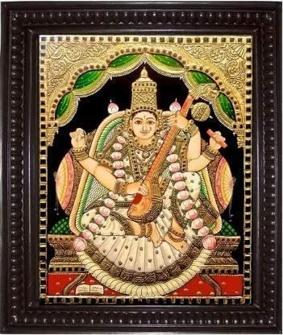 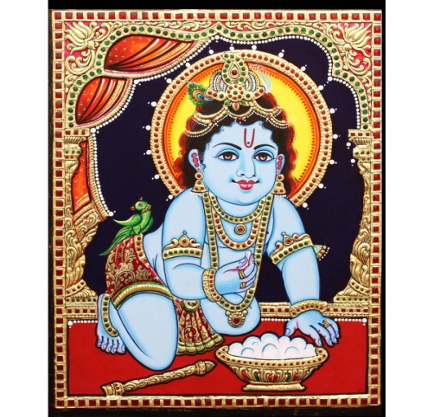

**RAJASTHANI PAINTING**

Rajasthani painting or Rajput painting evolved and flourished in the royal courts of Rajputana in Northern India mainly during the 17th century. The paintings usually depicted local traditions especially those illustrating the Hindu religious epics Ramayana and the Mahabharata.

The colors were extracted from certain minerals, plant sources, and conch shells and were even derived by processing precious stones. Gold and silver were used too and fine brushes were used.

|  |  |  |
| --- | --- | --- |
| Oil On Canvas Handmade Rajasthani paintings, Size: 30x48 Inches, | ID:  20561505130 | Rajasthani painting, Aurora sleeping beauty, Disney princess | Buy Rajasthani Painting Painting at Lowest Price by Seema Dasan |

**DEFINE THE FOLLOWING**

STRING INSRUMENTS

A musical instrument (such as a guitar, violin) that has strings and that produces sound when the strings are touched or struck.

1. Guitar

2. Electric Bass

3. Violin

4. Viola

5. Cello

6. Double Bass

7. Banjo

8. Mandolin

9. Ukulele

10. Harp

|  |  |  |
| --- | --- | --- |
| guitar.jpg | harp.jpg | violin.jpg |

**WIND INSTRUMENTS**

A musical instrument in which sound is produced by the vibration of air, typically by the player blowing into the instrument.

1. Horns

2. Trumpets

3. Trombones

4. Euphoniums

5. Tubas

6. Recorders

7. Flutes

8. Oboes

9. Clarinet

10. Saxophone

|  |  |  |
| --- | --- | --- |
| clarinet.jpg | saxophone.jpg | flut.jpg |